**Sample 4**

|  |  |
| --- | --- |
| 1. | How many of the following numbers are divisible by 132?  264, 396, 462, 792, 968, 2178, 5184, 6336 |

|  |  |  |  |
| --- | --- | --- | --- |
| [**A.**](javascript:%20void%200;) | 4 | [**B.**](javascript:%20void%200;) | 5 |
| [**C.**](javascript:%20void%200;) | 6 | [**D.**](javascript:%20void%200;) | 7 |

2. The largest 4-digit number exactly divisible by 88 is:

|  |  |  |  |
| --- | --- | --- | --- |
| [**A.**](javascript:%20void%200;) | 8888 | [**B.**](javascript:%20void%200;) | 9787 |
| [**C.**](javascript:%20void%200;) | 9999 | [**D.**](javascript:%20void%200;) | 9944 |

|  |
| --- |
| 3. What is the least number that must be added to 1056, so that the sum is completely divisible by 23? |
| |  |  |  |  | | --- | --- | --- | --- | | [**A.**](javascript:%20void%200;) | 2 | [**B.**](javascript:%20void%200;) | 3 | | [**C.**](javascript:%20void%200;) | 18 | [**D.**](javascript:%20void%200;) | 21 | |

|  |
| --- |
| 4. A man can cover a distance in 1 h 24 min by covering 2/3 of the distance at 4 km/h and the rest at 5 km/h. The total distance is: |
| |  |  |  |  | | --- | --- | --- | --- | | [**A.**](javascript:%20void%200;) | 5 km | [**B.**](javascript:%20void%200;) | 6 km | | [**C.**](javascript:%20void%200;) | 7 km | [**D.**](javascript:%20void%200;) | 8 km | |

5. The ratio between the speeds of two trains is 7: 8. If the second train runs 440 km in 4 hours, then the speed of the first train is:

**A.** 47.4 km/h  **B.** 57.19 km/h **C.** 68.13 km/h **D.** 96.25 km/h

**Every one of the following questions consists of a related pair of words, followed by four pairs of words. Choose the pair that best represents a similar relationship to the one expressed in the original pair of words.**

6. **BINDING: BOOK**

|  |  |  |  |
| --- | --- | --- | --- |
| [**A.**](javascript:%20void%200;) | criminal: gang | [**B.**](javascript:%20void%200;) | display: museum |
| [**C.**](javascript:%20void%200;) | nail: hammer | [**D.**](javascript:%20void%200;) | frame: picture |

7. **EXPLORE: DISCOVER**

|  |  |  |  |
| --- | --- | --- | --- |
| [**A.**](javascript:%20void%200;) | read: skim | [**B.**](javascript:%20void%200;) | research: learn |
| [**C.**](javascript:%20void%200;) | write: print | [**D.**](javascript:%20void%200;) | think: relate |

8. If ZEBRA can be written as 2652181, how can COBRA be written? http://books.tamilcube.com/image/blank.gifhttp://books.tamilcube.com/image/blank.gif

|  |  |  |  |
| --- | --- | --- | --- |
| [**A.**](javascript:%20void%200;) | 302181 | [**B.**](javascript:%20void%200;) | 3152181 |
| [**C.**](javascript:%20void%200;) | 31822151 | [**D.**](javascript:%20void%200;) | 1182153 |

|  |  |  |  |  |  |  |  |  |
| --- | --- | --- | --- | --- | --- | --- | --- | --- |
| **9. Here are some words translated from an artificial language.**  moolokarn means blue sky  wilkospadi means bicycle race  moolowilko means blue bicycle  Which word could mean "racecar"?   |  |  |  |  | | --- | --- | --- | --- | | [**A.**](javascript:%20void%200;) | wilkozwet | [**B.**](javascript:%20void%200;) | spadiwilko | | [C.](javascript:%20void%200;) | moolobreil | [**D.**](javascript:%20void%200;) | spadivolo | |

10. Look at this series: 70, 71, 76, __, 81, 86, 70, 91, ... What number should fill the blank?

|  |  |  |  |
| --- | --- | --- | --- |
| [**A.**](javascript:%20void%200;) | 70 | [**B.**](javascript:%20void%200;) | 80 |
| [**C.**](javascript:%20void%200;) | 71 | [**D.**](javascript:%20void%200;) | 96 |

11. Which figure completes the statement? http://books.tamilcube.com/image/blank.gif

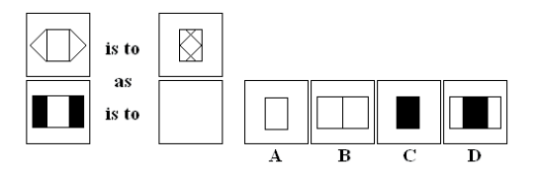

12. Which figure is the odd one out? http://books.tamilcube.com/image/blank.gif

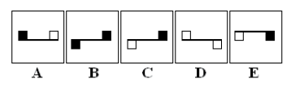

13. Which figure belongs in neither group?

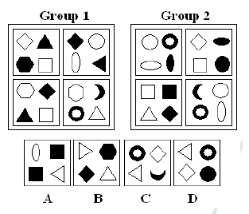

14. Which figure is next in the series?http://books.tamilcube.com/image/blank.gif

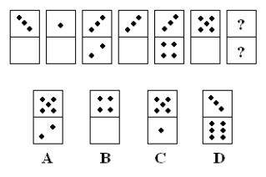

**Read the paragraph below and answer accordingly.**

“Grey wolf also known as the timber wolf or wolf is a mammal of the order Carnivore. Genetic studies indicate that the grey wolf shares a common ancestry with the domestic dog and might be its ancestor. Many other grey wolf subspecies have been identified, however, the actual number of subspecies is still open to discussion. Though once abundant over much of North America and areas of Europe and Asia, the grey wolf inhabits a very small portion of its former range because of the widespread destruction of its habitat. Grey wolves are highly adaptable and have thrived in forests, deserts, mountains, tundra and grasslands. They function as social predators and hunt in packs organized according to strict social hierarchies. It was originally believed that this comparatively high level of social organization was related to hunting success, and while this still may be true to a certain extent, emerging theories suggest that the pack has less to do with hunting and more to do with reproductive success.”

**15. We can understand from the passage that the grey wolf ----.**

A) can survive in a wide variety of habitats

B) prefers to hunt individually rather than in groups

C) was once found in every continent of the world in great numbers

D) has been proved to be the ancestor of the domestic dog and all its subspecies

E) and the timber wolf are two distinct species of wolf

**16. It is understood from the passage that ----.**

A) the number of grey wolf subspecies has been determined with certainty by researchers

B) there are few grey wolf subspecies which continue living today

C) grey wolf subspecies have increased in number in the last decades

D) it is known that many of grey wolf subspecies have already become extinct

E) there is no consensus on how many grey wolf subspecies exist

**17. According to the passage, in the light of the genetic studies carried out, it has been found out that ----.**

A) the domestic dog could have descended from the grey wolf

B) the grey wolf and the domestic dog are the subspecies of a kind of wolf having lived thousands of years ago

C) the dog is believed to be ancestor of the grey wolf

D) grey wolves live in very large packs

E) grey wolves live only in Europe and Asia today

---------------------------------------------------------------------------------------------------------------------

**Opera refers to a dramatic art form, originating in Europe, in which the emotional content is conveyed to the audience as much through music, both vocal and instrumental, as it is through the lyrics. By contrast, in musical theater an actor's dramatic performance is primary, and the music plays a lesser role. The drama in opera is presented using the primary elements of theater such as scenery, costumes, and acting. However, the words of the opera, or libretto, are sung rather than spoken. The singers are accompanied by a musical ensemble ranging from a small instrumental ensemble to a full symphonic orchestra.**

**18. It is pointed out in the reading that opera ----.**

A) has developed under the influence of musical theater

B) is a drama sung with the accompaniment of an orchestra

C) is not a high-budget production

D) is often performed in Europe

E) is the most complex of all the performing arts

**19. We can understand from the reading that ----.**

A) people are captivated more by opera than musical theater

B) drama in opera is more important than the music

C) orchestras in operas can vary considerably in size

D) musical theater relies above all on music

E) there is argument over whether the music is important or the words in opera

**20. It is stated in the reading that ----.**

A) acting and costumes are secondary to music in musical theater

B) many people find musical theater more captivating than opera

C) music in musical theater is not as important as it is in opera

D) an opera requires a huge orchestra as well as a large choir

E) opera doesn't have any properties in common with musical theater